**DELHI TECHNOLOGICAL UNIVERSITY**



**DATABASE MANAGEMENT SYSTEM**

**LAB PROJECT**

INDIAN PREMIER LEAGUE (IPL) DATABASE

**SUBMITTED TO: SUBMITTED BY:**

Mr. MANOJ SETHI VAIBHAV RAJ SAHNI

2K19/CO/419

**ACKNOWLEDGEMENT**

I would like to express a deep sense of thanks and gratitude to my teacher Mr. Manoj Sethi for giving me the golden opportunity to do this project on the topic “INDIAN PREMIER LEAGUE (IPL) Database” and guiding me immensely through the course of the project. His constructive advice and constant motivation have been responsible for the successful completion of the project.

I would also like to thank Mr. Yogesh Singh, our Vice-Chancellor, for his co-ordination in extending every possible support for completion of this project.

Last but not the least, I would like to thank all those who had helped me directly or indirectly towards the completion of the project.

**CERTIFICATE**

This is to certify that Vaibhav Raj Sahni (2K19/CO/419) has successfully completed the Database Management Lab Project entitled “INDIAN PREMIER LEAGUE (IPL) Database”. The project report is a result of his efforts and endeavors. The project is found worthy of acceptance as final project for Database Management Systems Lab. The project has been prepared under my knowledge consistently.

Mr. Manoj Sethi

(DBMS Teacher)

**CONTENTS**

* Introduction
* Proposed work
* Implementation
* Entity Relationship Diagram
* Normalisation
* Schema
* Data Pre-processing
* Creating database
* Importing data
* Adding Constraints
* Results
* Conclusion
* References

**INTRODUCTION**

The Indian Premier League (IPL) is a professional Twenty20 Cricket league in India usually contested between March and May of every year by eight teams representing eight different cities or states in India.The league was founded by the Board of Control for Cricket in India (BCCI) in 2007 and its first season was played in 2008. Ever since then, 13 seasons of IPL have been played and its elaborate ball-by-ball data amounts to a whole database system. In this project, I will build a MySQL database using dataset taken from Kaggle.com. The dataset consists of 6 compressed comma-separated-value (.csv) files that are downloaded from the same.

**Dataset Used**

Each dataset is contained in a comma-separated-values (csv) formatted file in the UTF-8 character set. The first line in each file contains headings for that column. A “ ” (blank space) is used to denote that a particular field is missing or has a NULL value for varchar inputs while integer inputs which were earlier also stored in similar format were changed to an integer 0 to rectify the anomaly. It should be noted that the data available for download from Kaggle.com is from 2008 to 2016 and serves our purpose. The available IPL data files are as follows:

**Ball_by_Ball.csv**

Contains the following information for ball-by-ball data:

• Match_Id(integer)- identifies which match is the data from

• Innings_Id (integer) – identifies which innings of the match is the data from

• Over_Id(integer) - identifies which innings of the match is the data from

• Ball_Id (integer) - identifies which ball of the over is the data from

• Team_Batting_Id (integer) - identifies team_id of the team currently batting

• Team_Bowling_Id (integer) - identifies team_id of the team currently bowling

• Striker_Id (integer) - gives player_id of the player who is on the striker’s end

• Striker_Batting_Position (integer) - gives the batting position of the striker

• Non_Striker_Id (integer) - gives player_id of the player who is on the non-striker’s end

• Bowler_Id (integer) - gives player_id of the player who is bowling currently

• Batsman_Scored (integer) - number of runs scored on the current ball

• Extra_Type (varchar) - states the type of extra run scored on the current ball if any

• Extra_Runs (integer) - number of extra runs on the current ball if any

• Player_Dismissal_Id (integer) - gives player_id of the player who is dismissed, else gives 0 as value.

• Dismissal_Type (varchar) - identifies the type of dismissal

• Fielder_Id (integer) - identifies player_id of the fielder involved

**Matches.csv**

Contains the following information for matches:

• Match_Id (integer) - a number to uniquely identify each match

• Team_Name_Id (integer) – gives team_id of one of the teams

• Opponent_Team_Id (integer) – gives team_id of the opponent team

• Season_Id (integer) - identifies which season of the IPL is the data from

• Venue_Name (varchar) – states the name of the venue

• Toss_Winner_Id (integer) - gives team_id of the team who won the toss

• Toss_Decision (varchar) - states if the toss winning team chose to bat or field

• Is_Superover (boolean) - identifies if the match was decided by a superover

• Is_Result (boolean) - identifies if the match was completed or ended in “No Result”

• Is_DuckWorthLewis (boolean) - identifies if the match was decided Duckworth Lewis System (DLS)

• Win_Type (varchar) - states if the match was won “by runs”, “by wickets” or resulted in a “tie”

• Won_By (integer) - gives number of wickets or runs by which match decision was made

• Match_Winner_Id (integer) - gives team_id of the team that won the match

• Man_Of_The_Match_Id (integer) - gives player_id of the player who won the man of the match award

• First_Umpire_Id (integer) - gives player_id of the First Umpire

• Second_Umpire_Id (integer) - gives player_id of the Second Umpire

• City_Name (varchar) – states the city in which the match is being played

• Host_Country (varchar) - states the country in which the match is being played

**Player.csv**

Contains the following information for players:

• Player_Id (integer) - a number to uniquely identify each player

• Player_Name (varchar) - states the name of the player

• Batting_Hand (varchar) – states if the player bats right-handed or left-handed

• Bowling_Skill (varchar) – states the bowling arm and bowling technique

• Country (varchar) - states the country in which the match is being played

• Is_Umpire (boolean) - identifies if the current player is an umpire

**Season.csv**

Contains the following information for seasons:

• Season_Id (integer) - a number to uniquely identify each season

• Season_Year (integer) - identifies which year is the data from

• Orange_Cap_Id (integer) - gives player_id of the player who scored the highest runs in the season

• Purple_Cap_Id (integer) - gives player_id of the player who took the highest number of wickets in the season

• Man_Of_The_Series_Id (integer) - gives player_id of the player who won the man of the series award

**Team.csv**

Contains the following information for teams:

• Team_Id (integer) - a number to uniquely identify each team

• Team_Name (varchar) - states the name of the team

• Team_Short_Code (varchar) - states the short hand name used for the team

**Player_Match.csv**

Contains the following information:

• Match_Id(integer)- identifies which match is the data from

• Player_Id (integer) - gives player_id of the concerned player

• Team_Id (integer) - gives team_id of the concerned player

• Is_Keeper (boolean) - identifies if the current player is a wicket-keeper

• Is_Captain (boolean) - identifies if the current player is the captain of the team

**PROPOSED WORK**

The purpose of this project is to do the following:

• Learn about and use the database management system MySQL.

• Learn the essentials of database design, e.g., Entity-Relationship diagrams, logical schema, etc.

• Debug dataset anomalies using python script to replace blank spaces by 0 for integer values.

• Practice database queries by posing basic and more advanced queries using MySQL.

The project objectives include:

• Understand the data in the IPL dataset.

• Design a relational database and store the IPL data in it.

* Model the database using an Entity-Relationship (ER) diagram
* Perform normalisation
* Create a logical schema
* Create MySQL database
* Load data into the database
* Add primary and foreign key constraints

• Write SQL queries using different constraints, clauses and rules of the Structured Query Language and display their results as well

**IMPLEMENTATION**

**ENTITY RELATIONSHIP DIAGRAM**

Entity Relationship Diagram, also known as ERD is a type of flowchart that illustrates how “entities” such as people, objects or concepts relate to each other within a system. In other words, ER diagrams help to explain the logical structure of databases. They are created based on three basic concepts: entities, attributes and relationships. they use a defined set of symbols such as rectangles, diamonds, ovals and connecting lines to depict the inter-connectedness of entities, relationships and their attributes. The ER diagram of my database consists looks like this:

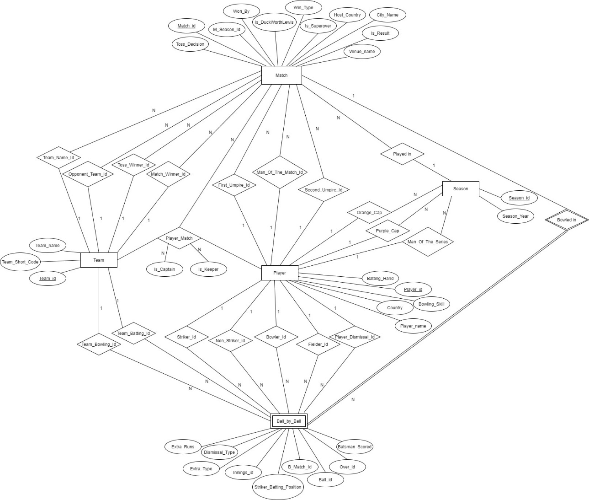

**­NORMALISATION**

Normalization is the process of organizing the data in the database. Normalization is used to minimize the redundancy from a relation or set of relations. It is also used to eliminate the undesirable characteristics like Insertion, Update and Deletion Anomalies. Normalization divides the larger table into the smaller table and links them using relationship. The normal form is used to reduce redundancy from the database table.

The conditions for 1NF, 2NF and 3NF are checked. This ER diagram is in 1 NF form due to the absence of multivalued attributes in any of the relations.

Following the second normal form, every non-prime attribute should be fully functionally dependent on prime key attribute. That is, if X → A holds, then there should not be any proper subset Y of X, for which Y → A also holds true. This means there should be no partial dependency. This condition is satisfied by all the relations and hence they are in second normal form.

For a relation to be in Third Normal Form, it must be in Second Normal form and no non-prime attribute must be transitively dependent on prime key attribute and for any non-trivial functional dependency, X → A, then either −

* + X is a super key or,
  + A is prime attribute.

This condition is also satisfied by all the relations, that means, they are in the third normal form.

**SCHEMA**

A database schema represents the logical configuration of all or part of a relational database. It can exist both as a visual representation and as a set of formulas known as integrity constraints that govern a database. These formulas are expressed in a data definition language, such as SQL. A database schema defines its entities and the relationship among them. It contains a descriptive detail of the database, which can be depicted by means of schema diagrams.

The logical schema of my database consists of 6 tables or relations:

* Ball_by_Ball
* Matches
* Player
* Team
* Season
* Player_Match

**BALL_BY_BALL**

Team_Batting_Id

Batsman_Scored

Over_Id

Innings_Id

B_Match_Id

Striker_Batting_Position

Ball_Id

Extra_Runs

Team_Bowling_Idd

Striker_Id

BALL_BY_BALL

Non_Striker_Id

Bowler_Id

Extra_Type

Fielder_Id

Dismissal_Type

BALL_BY_BALL

Player_Dismissal_Id

**MATCHES**

Opponent_Team_Id

M_Season_Id

Venue_Name

Win_Type

Match_Id

BALL_BY_BALL

Is_Result

Match_Winner_Id

Toss_Decision

Toss_Winner_Id

Is_Superover

First_UmBALL_BY_BALL

First_Umpire_Id

Team_Name_Id

Is_DuckWorthLewis

Won_By

Man_Of_The_Match_Id

BALL_BY_BALL

Second_Umpire_Id

City_Name

Host_Country

**PLAYER**

Player_Name

Player_Id

Country

Bowling_Skill

Batting_Hand

BALL_BY_BA

Is_Umpire

BALL_BY_BA

**PLAYER_MATCH**

PM_Match_Id

PM_Player_Id

Is_Captain

Is_Keeper

PM_Team_Id

BALL_BY_BALL

­­­

**SEASON**

Orange_Cap_Id

Season_Year

Purple_Cap_Id

Man_Of_The_Series_Id

Season_Id

BALL_BY_BALL

**TEAM**

Team_Short_Code

BALL_BY_BALL

Team_Name

Team_Id

­­­­­

**PRE-PROCESSING DATA**

The data collected had some inconsistencies and thus, the data could not be imported properly. For example, in an integer field where the answer was supposed to be zero, instead in the csv file, it was stored as “ ” (blank space), which is a character value. Therefore, python scripts were written for this data pre-processing to convert these blank spaces to the value 0.

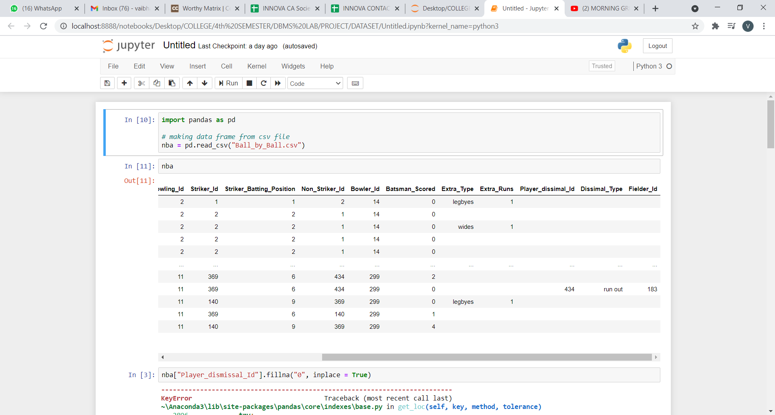

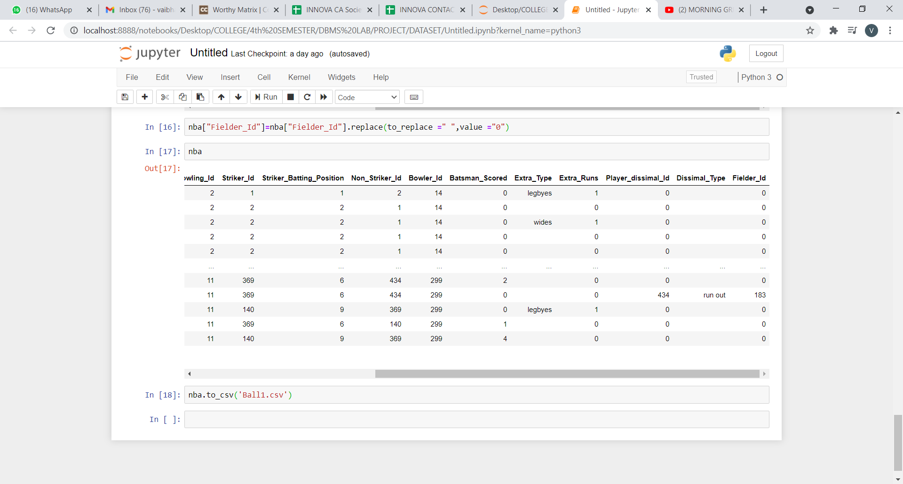

**CREATING THE DATABASE**

After creating the ER diagram and logical schema, the database was created in mySQL using SQL. Structured Query Language (SQL) is a database language by the use of which we can create a database and also perform certain operations on the existing database. SQL can be used as a Data Definition Language (DDL) by using the SQL commands that can be used to define the database schema. It simply deals with descriptions of the database schema and is used to create and modify the structure of database objects in the database.

The database was created using the CREATE DATABASE command

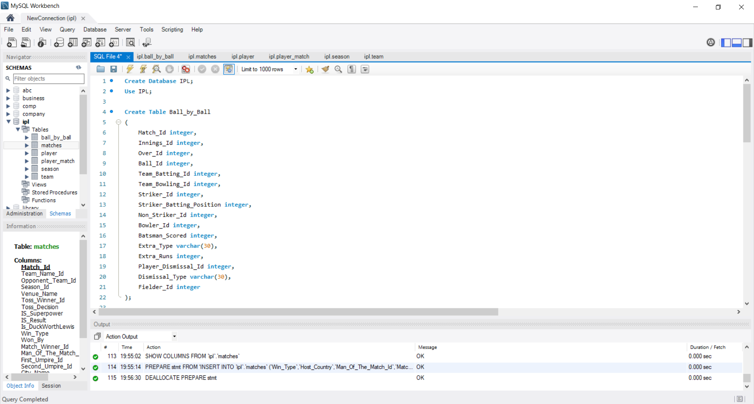

The tables were created using the CREATE TABLE command

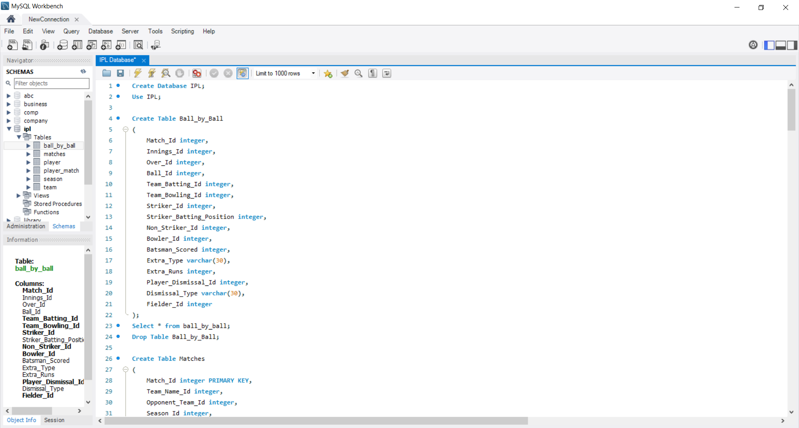 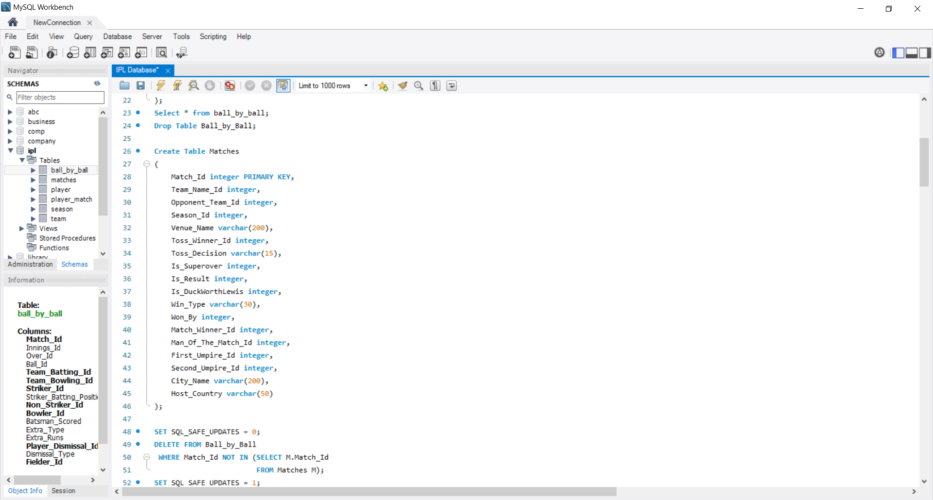

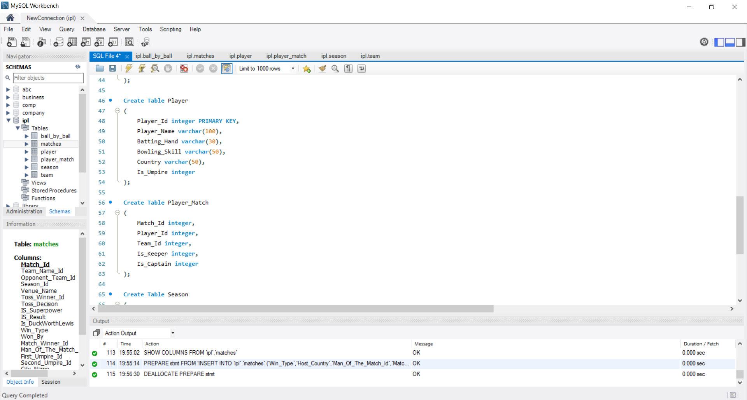

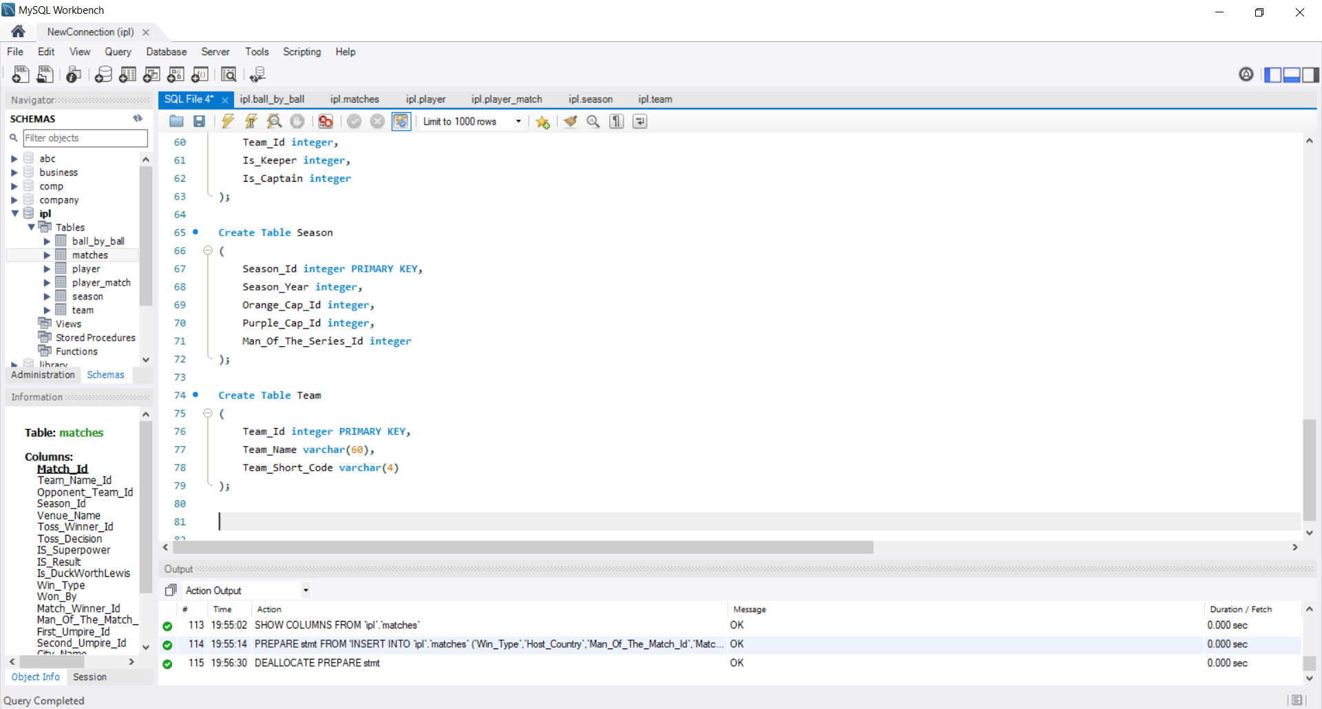



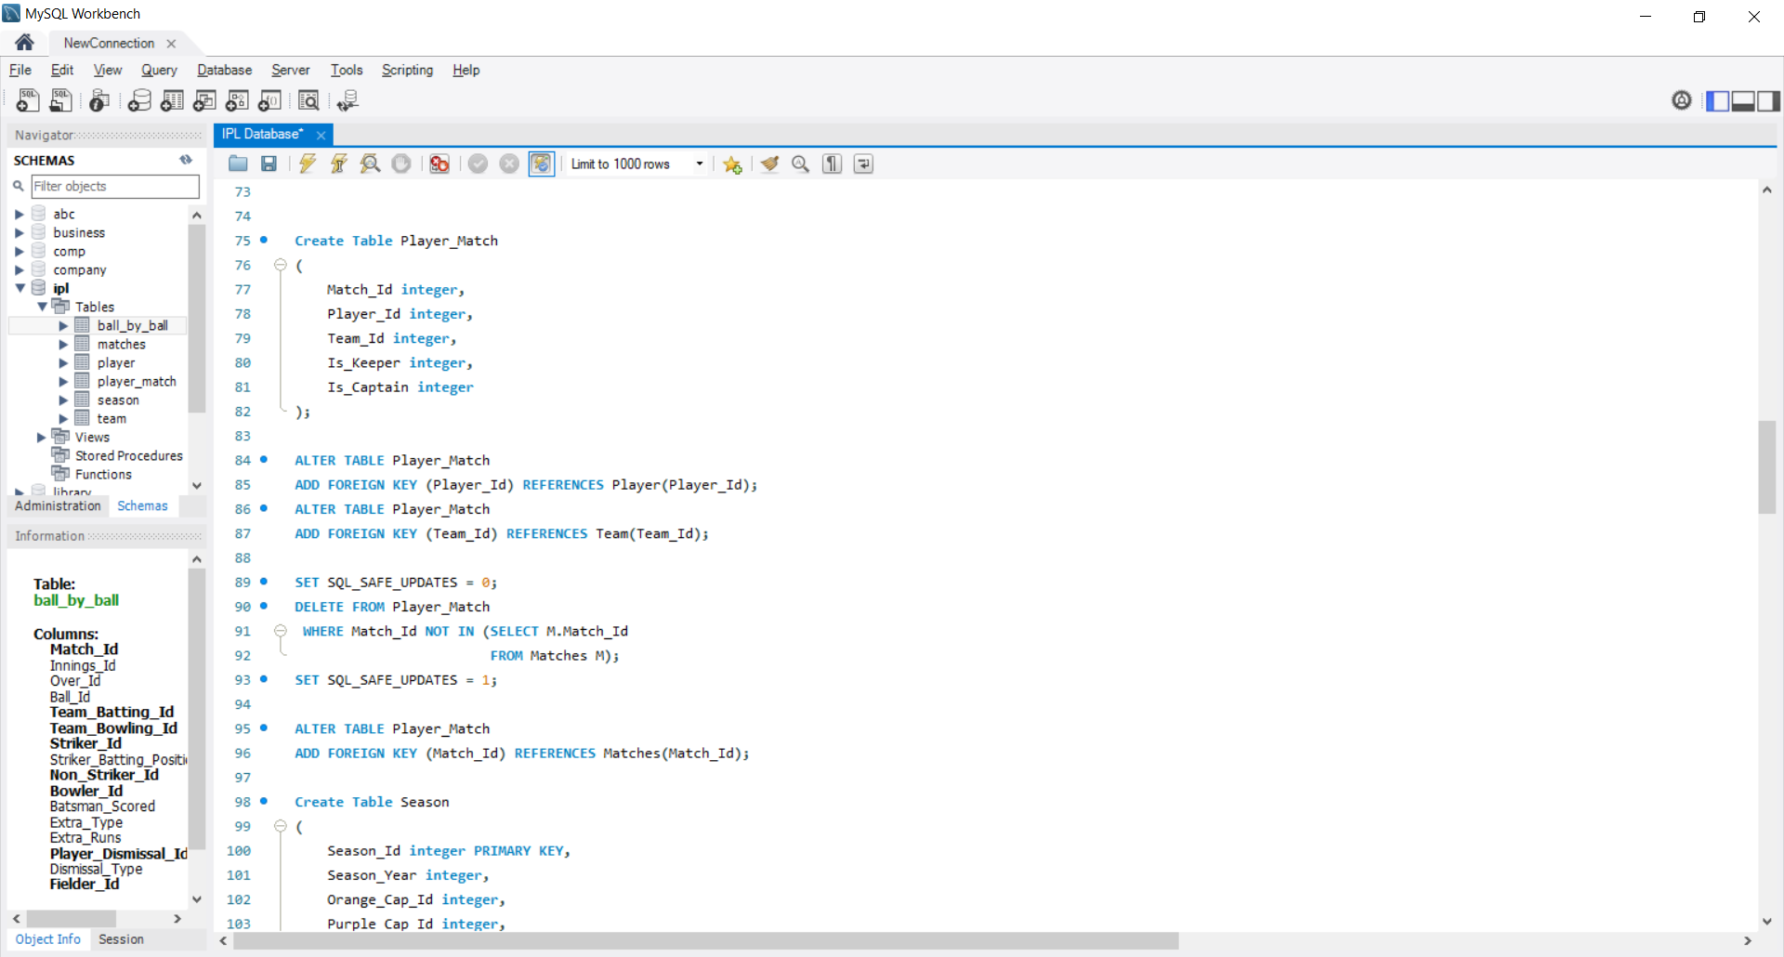

**IMPORTING THE DATA**

After creating the database schema in mySQL, the next step is to import the data into the created tables. The data has already been pre-processed and ready to be imported. The files to be imported are of very large size, with some of them having records as much as 1.3 Lakhs. The csv files were then directly imported using the Table Data Import Wizard feature of MySQL WorkBench.

**ADDING CONSTRAINTS**

Next, all the foreign key constraints were added in the respective tables:

* Ball_by_Ball

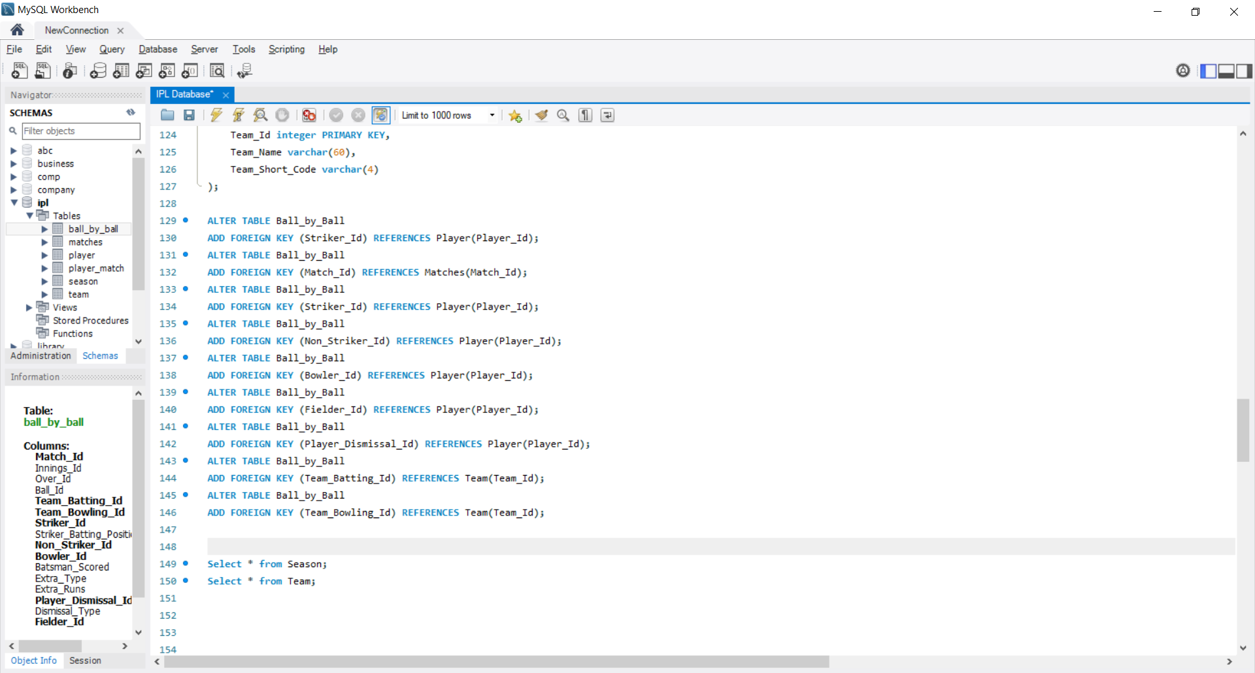

* Matches

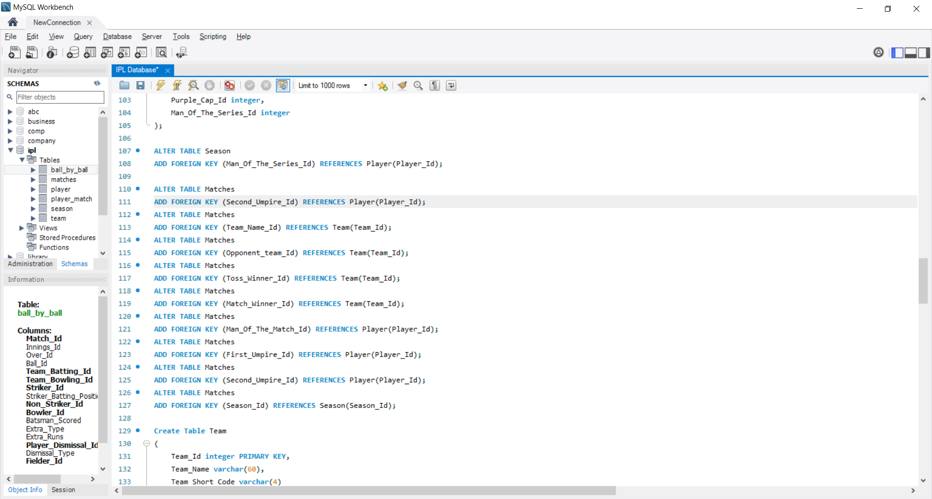

* Season

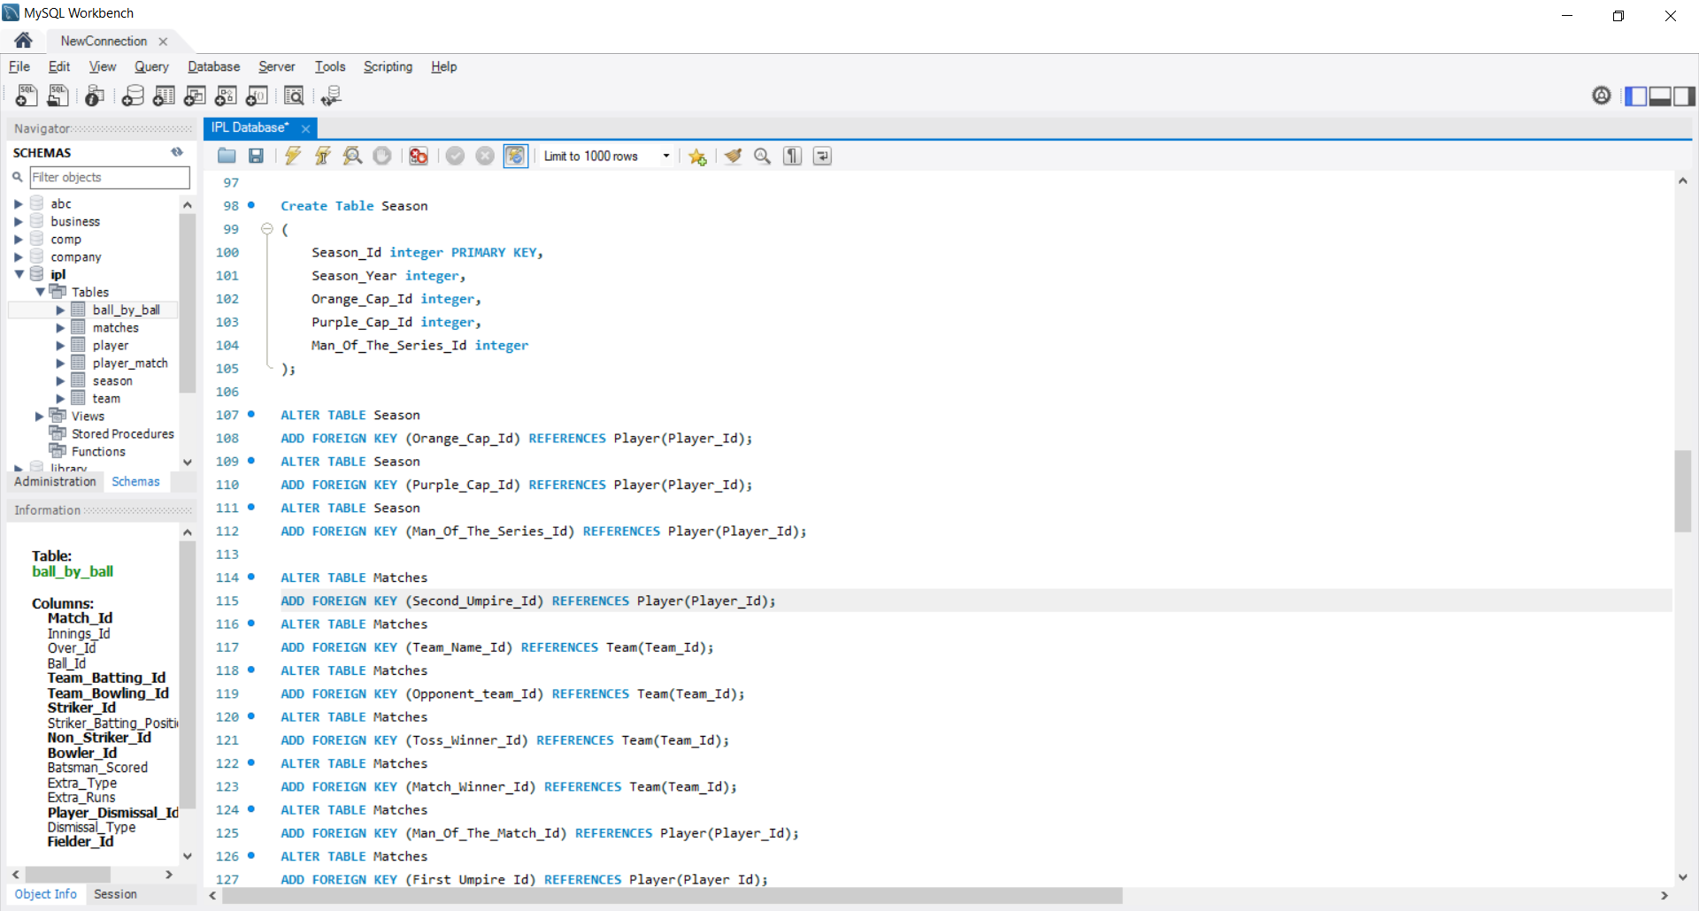

* Player_Match

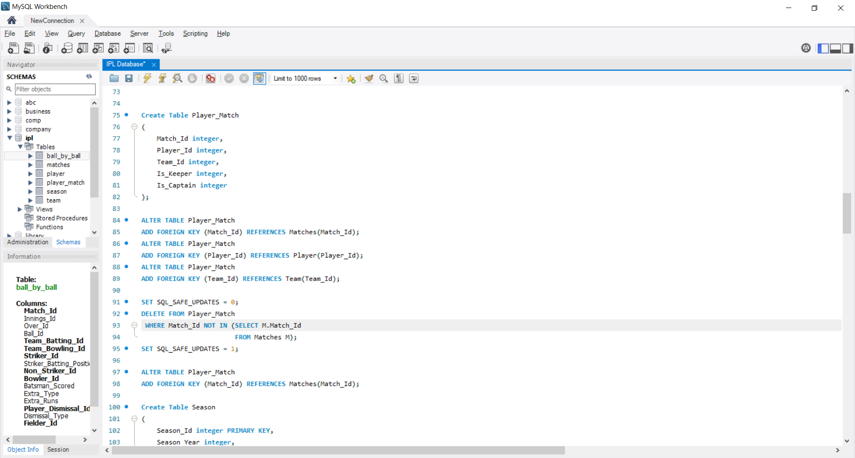

**RESULTS**

**SQL QUERIES**

1. How many matches of the IPL have been hosted by which countries?

**QUERY**

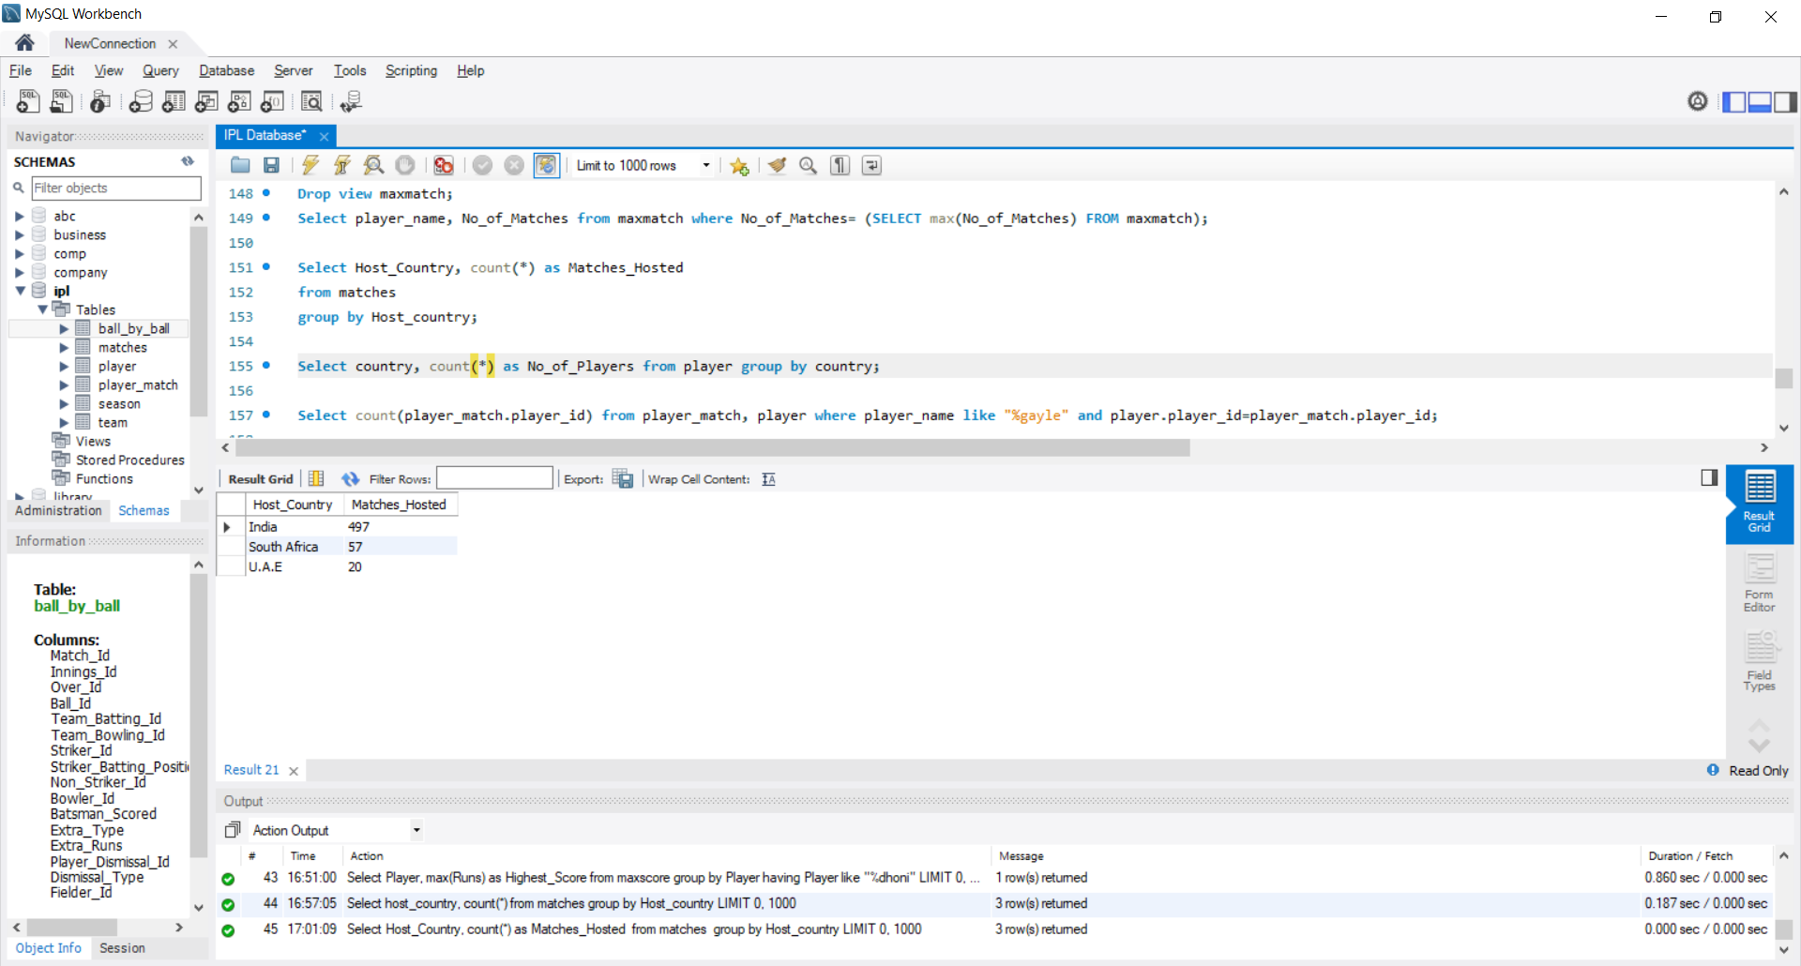

**OUTPUT**



1. How many players from each country have played in the IPL?

**QUERY**

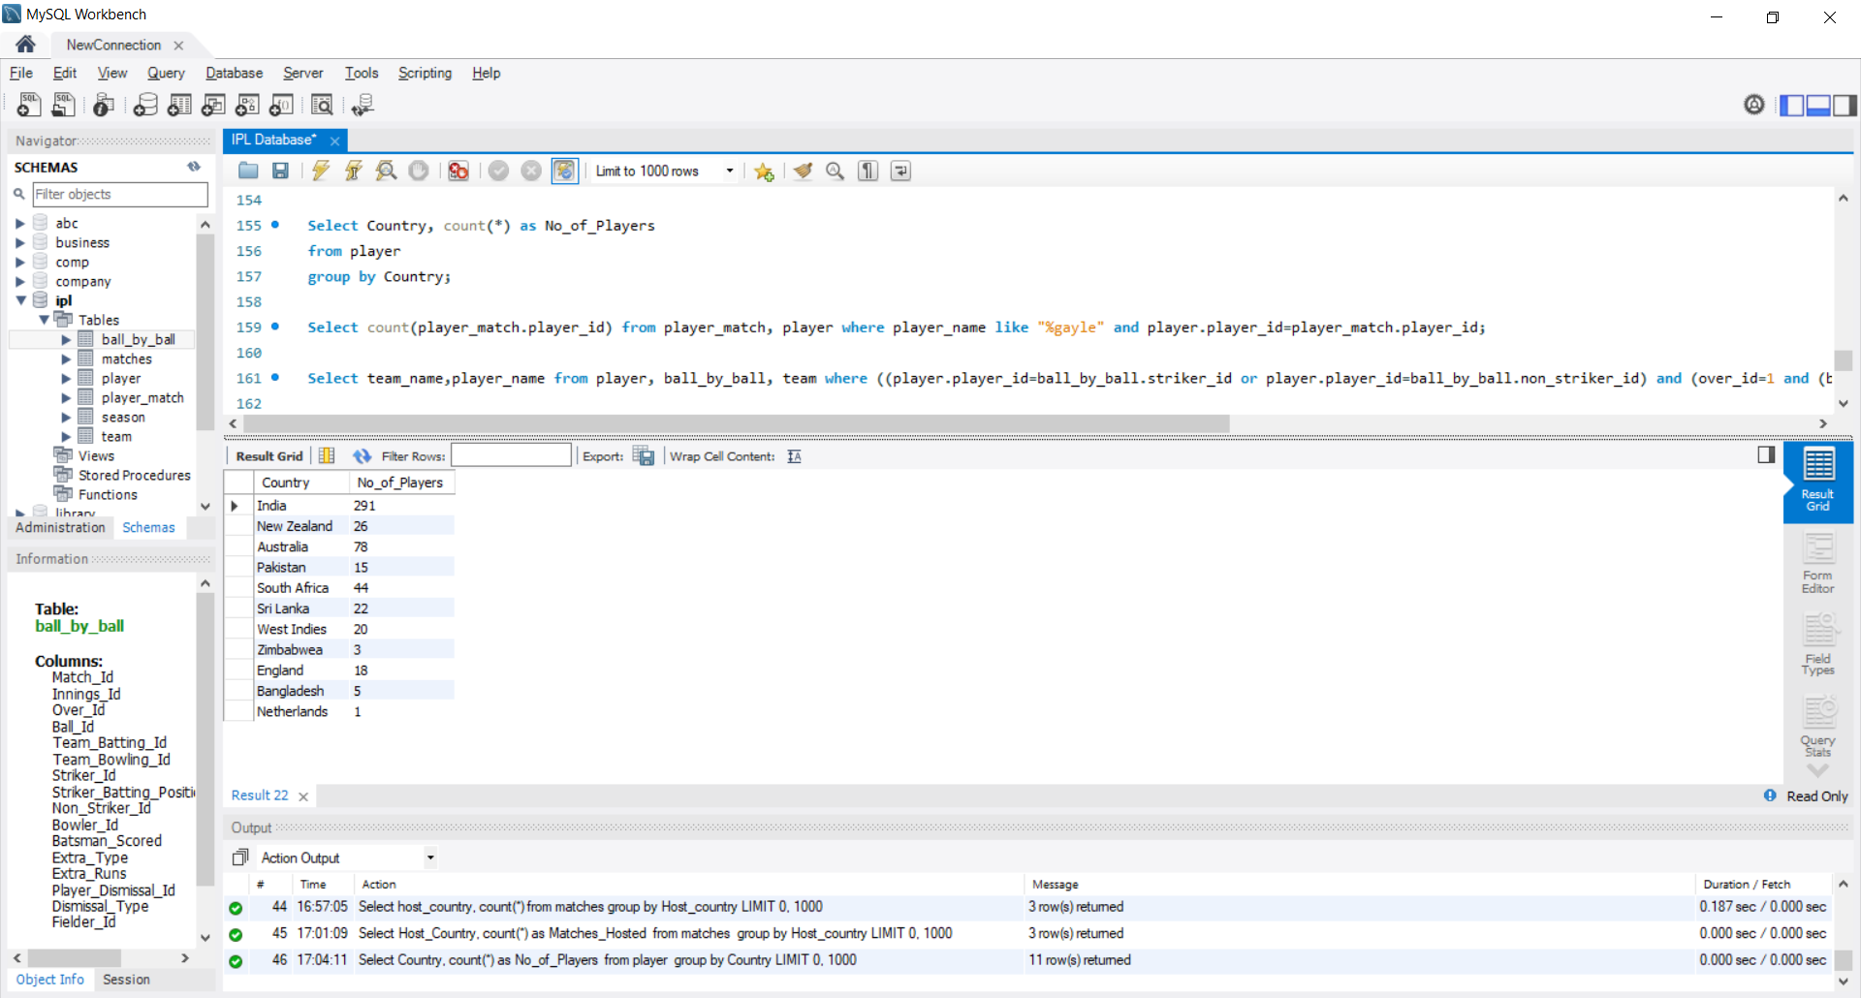

**OUTPUT**



1. Name all the players who have opened the batting for the “Chennai Super Kings”.

**QUERY**

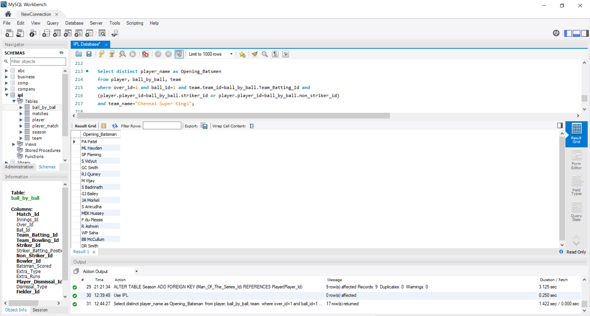

**OUTPUT**

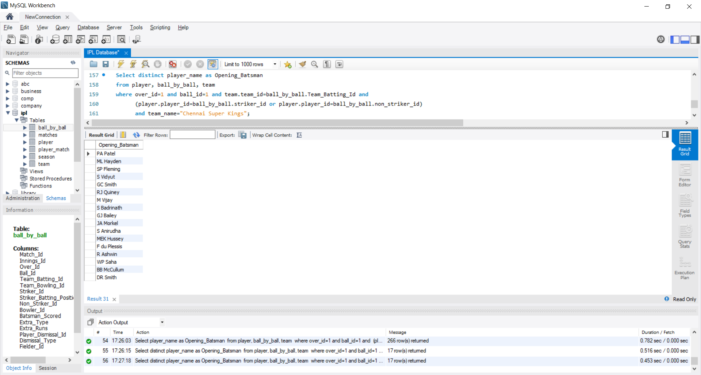

1. What is the total number of players that each team has recruited?

**QUERY**

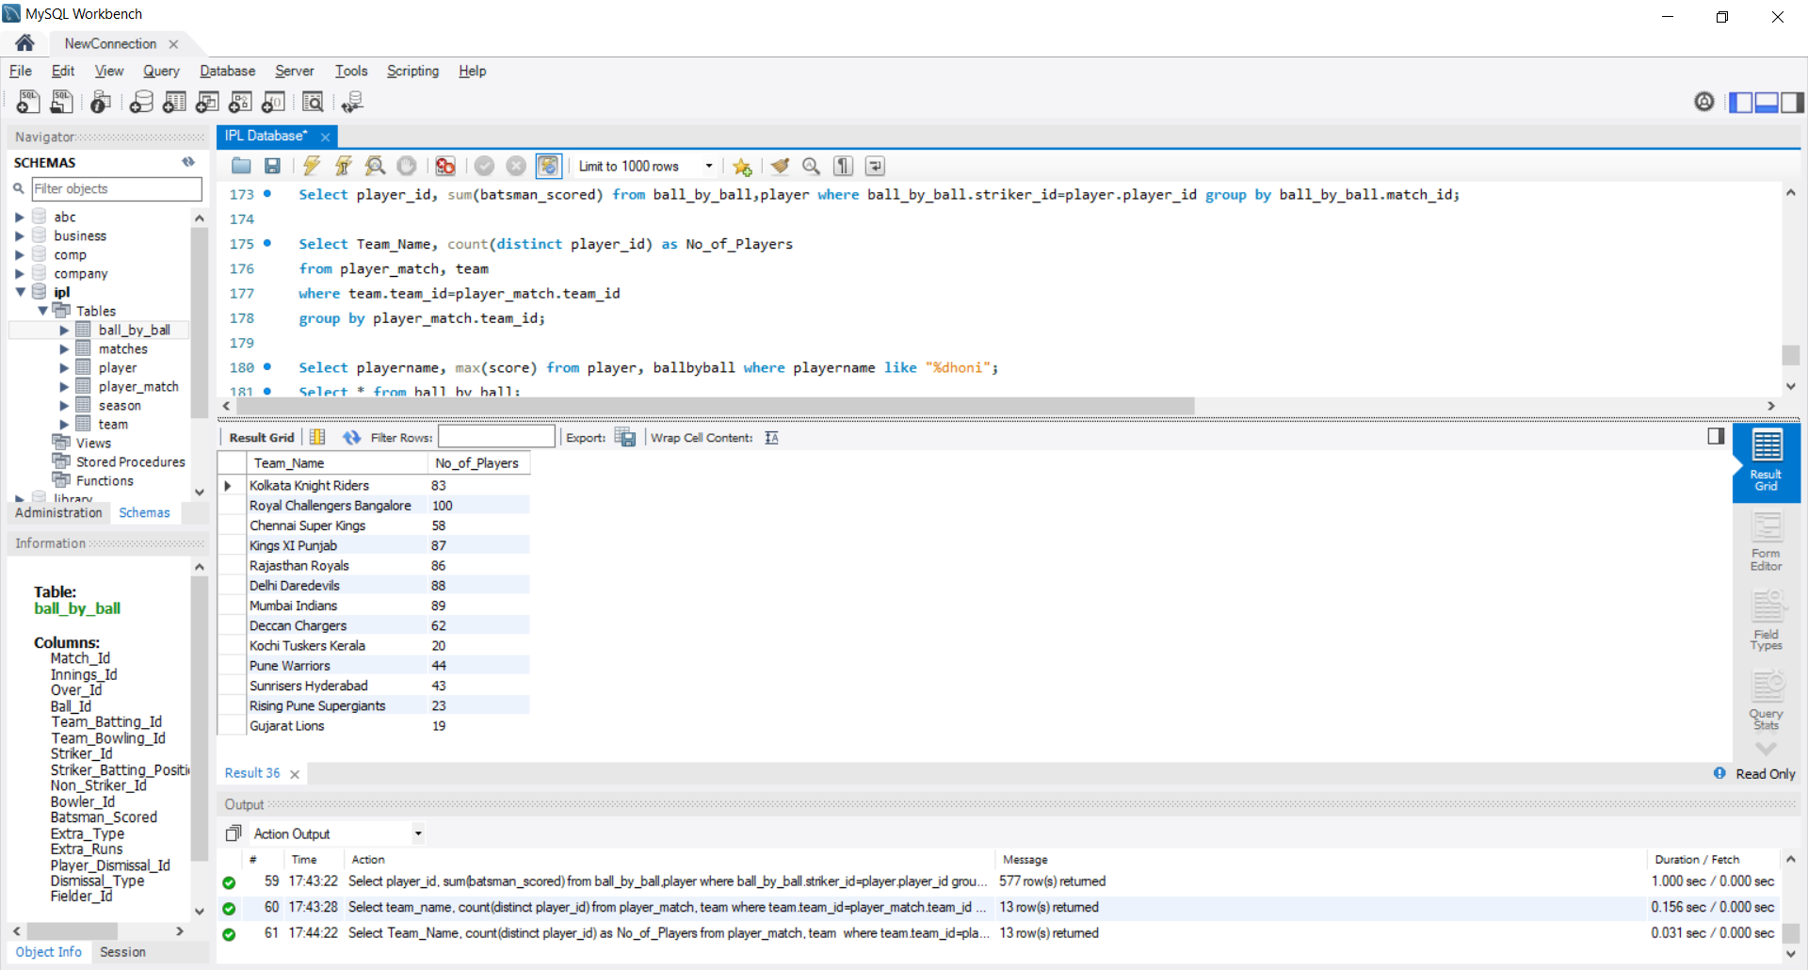

**OUTPUT**



1. List the total number of matches won by runs, by wickets and those which were tied.

**QUERY**

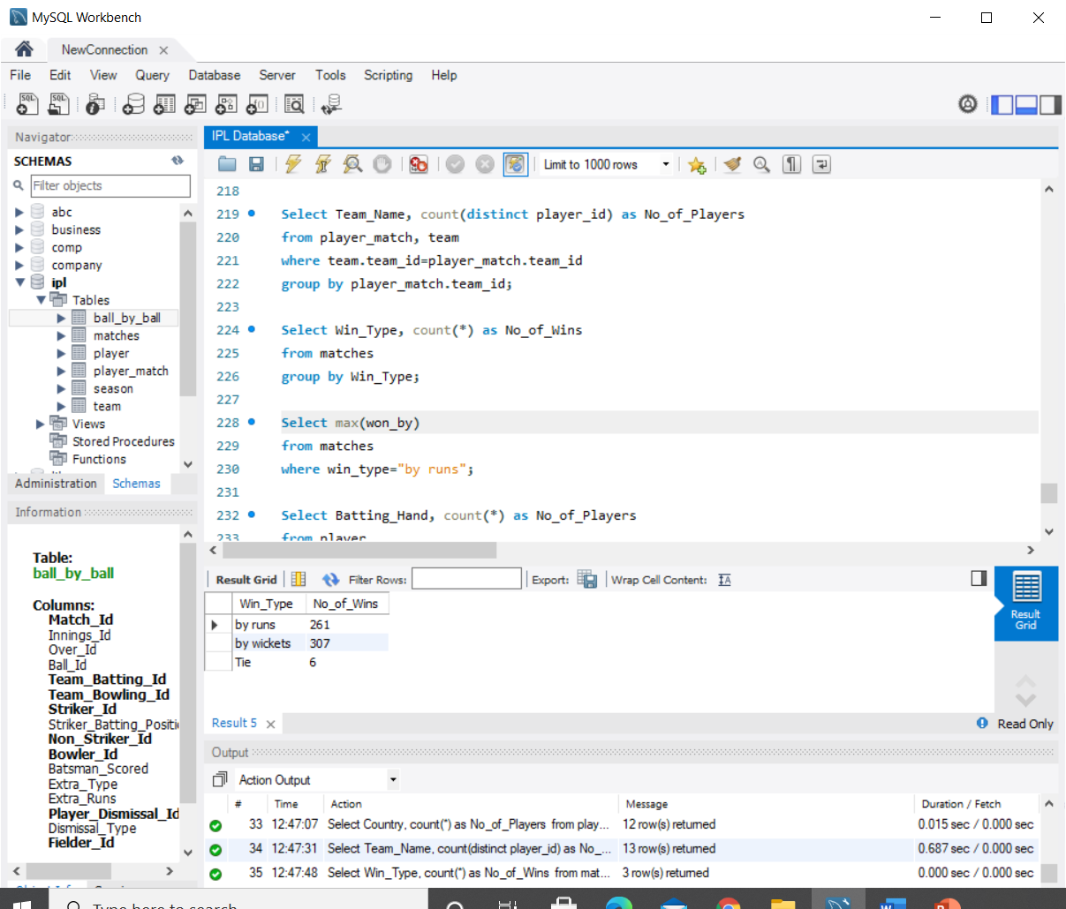

**OUTPUT**



1. List the top 50 players with the greatest number of Man of the Match Award wins.

**QUERY**

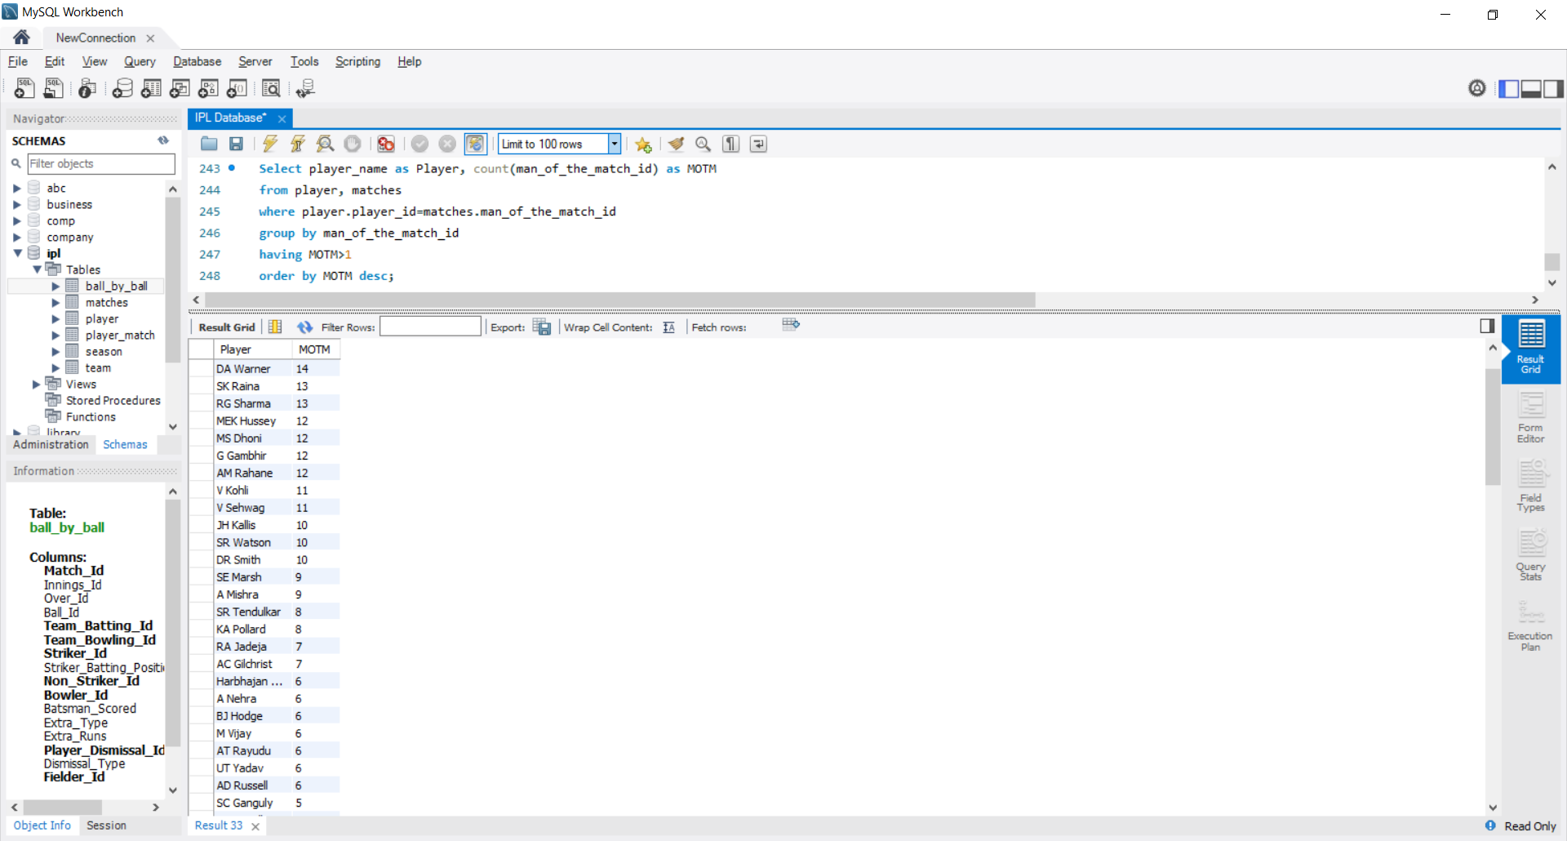

**OUTPUT**

 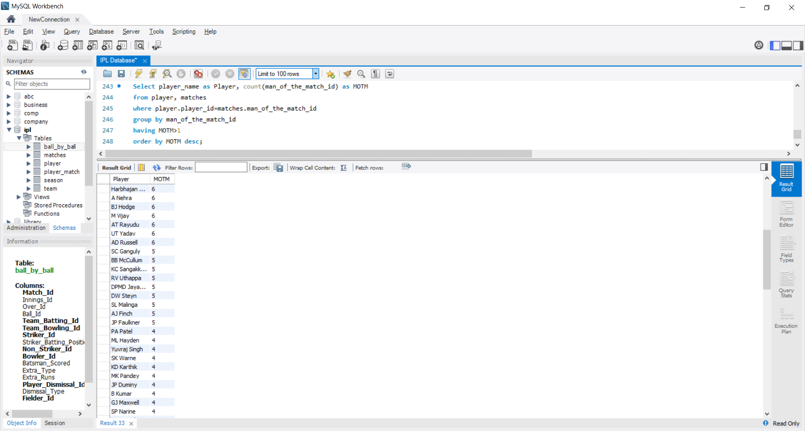

1. What is the total number of left-handed and right-handed batsmen that have played in the IPL?

**QUERY**

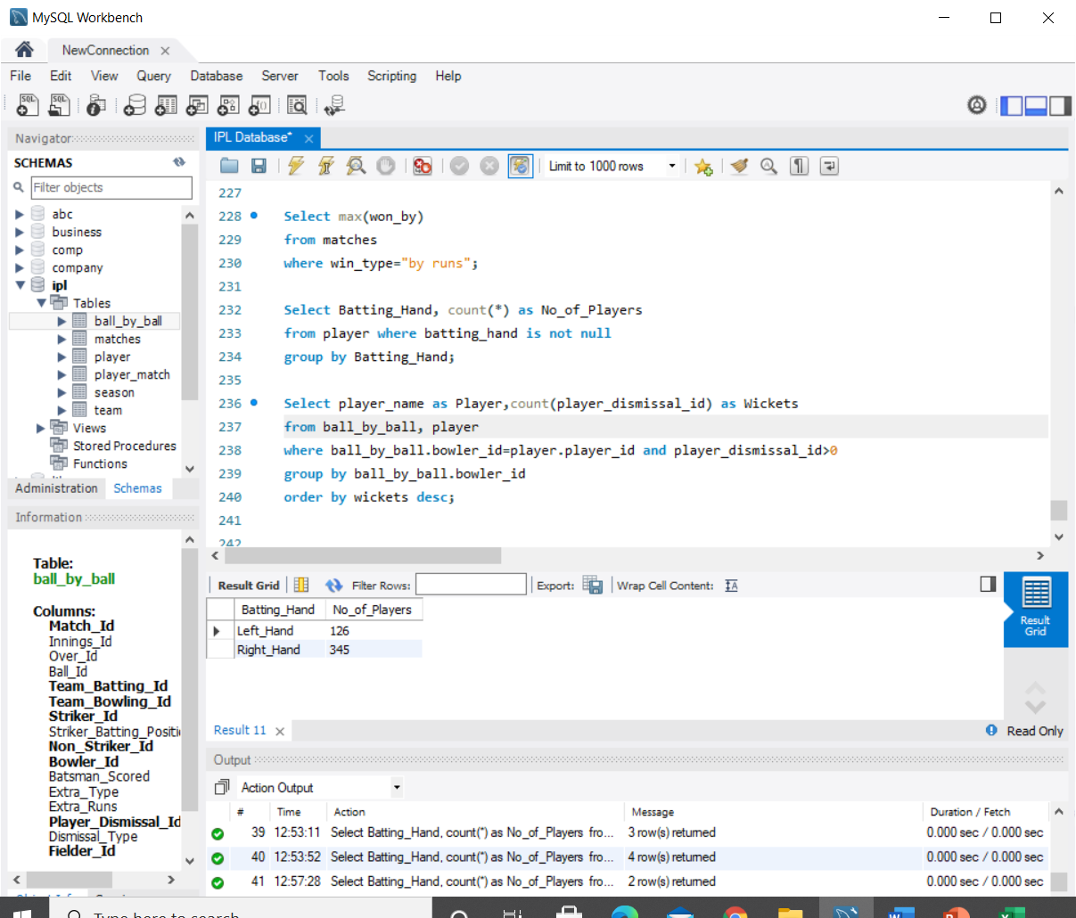

**OUTPUT**



1. Which team has won a game with the highest margin of runs?

**QUERY**

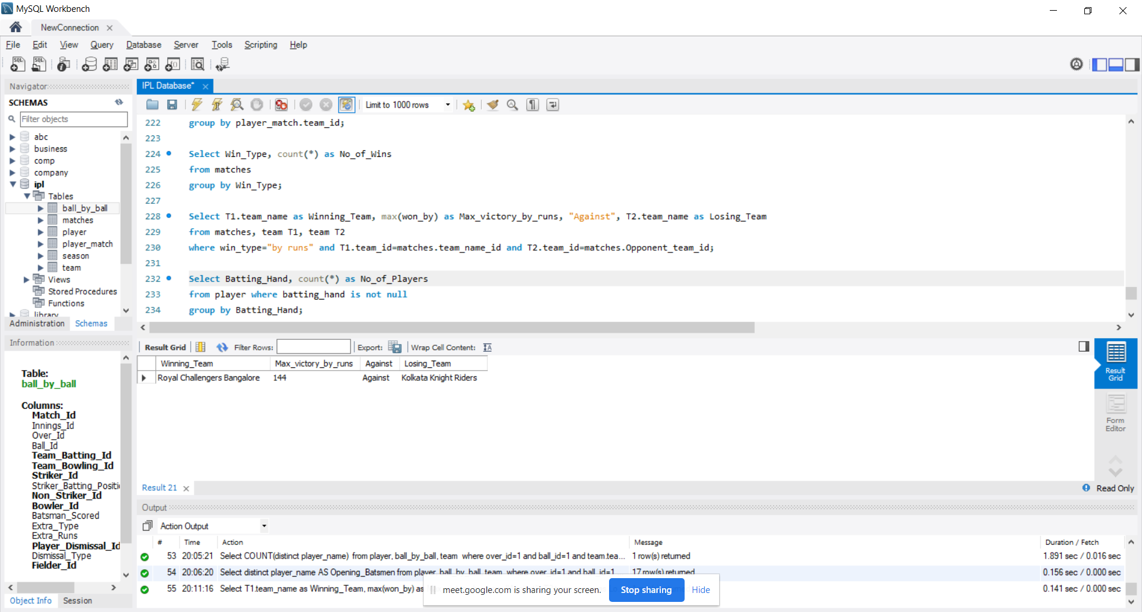

**OUTPUT**



1. Name all the players and their score who have scored a century.

**QUERY**

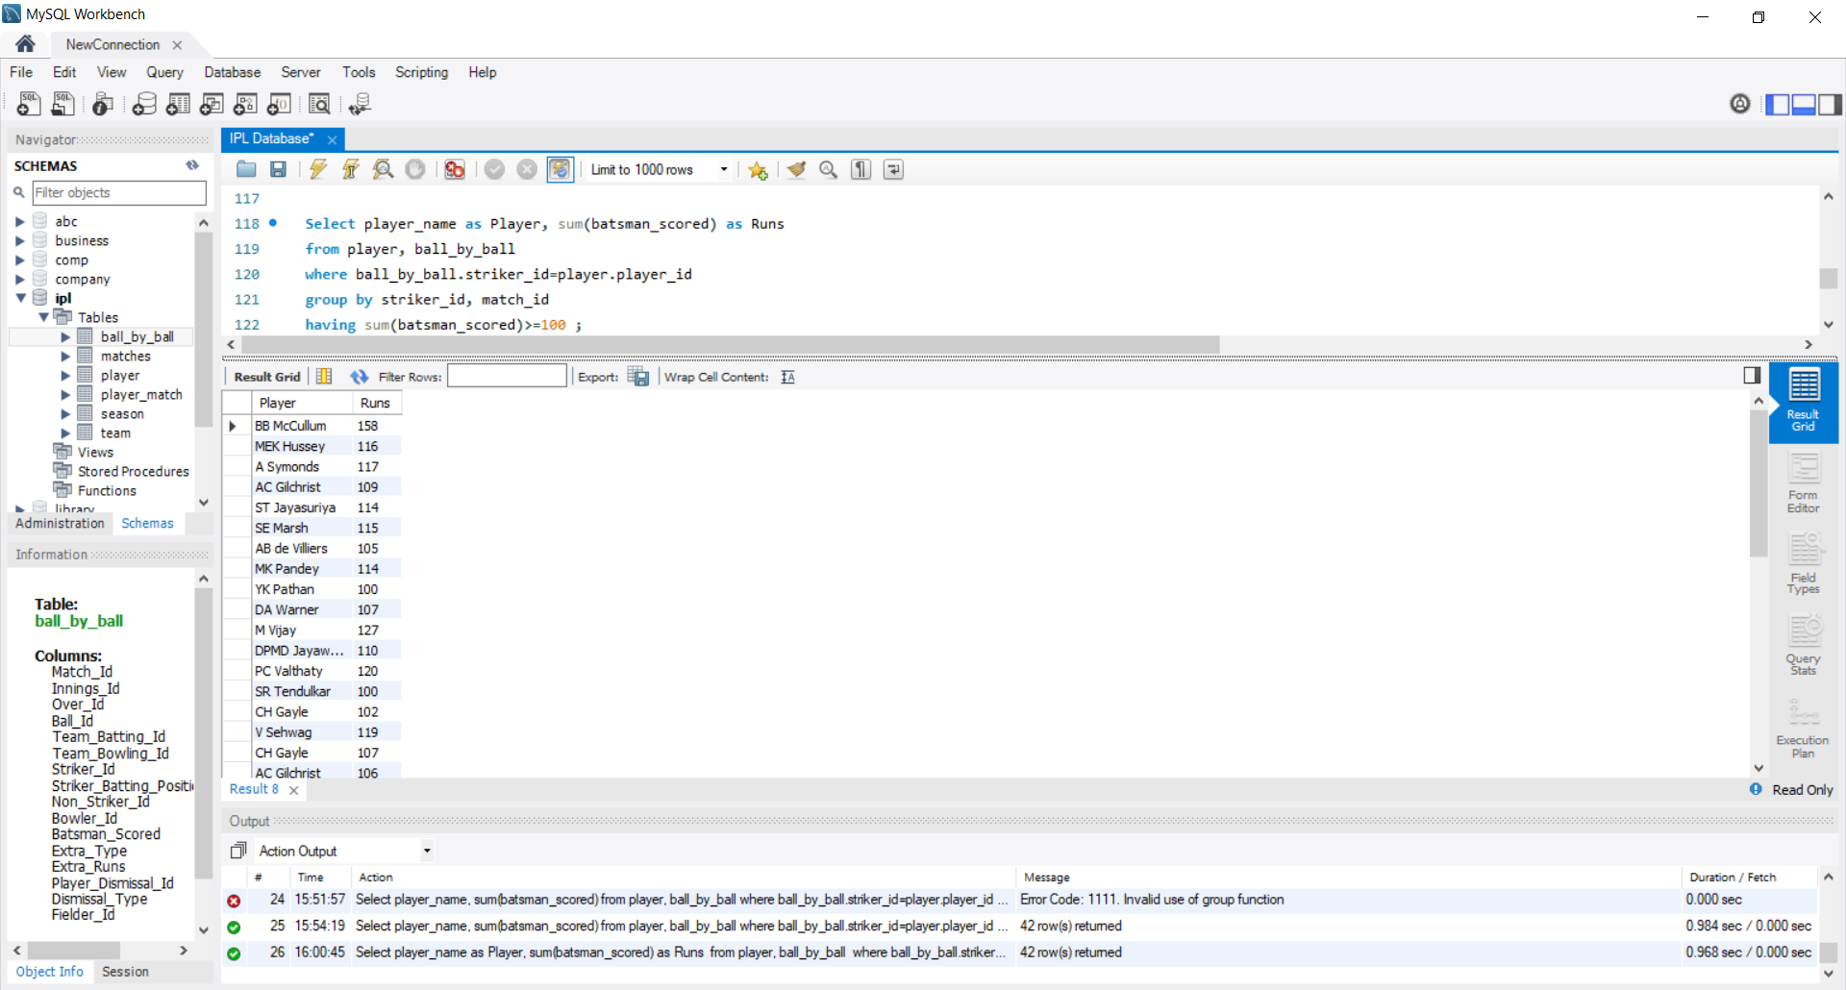

**OUTPUT**

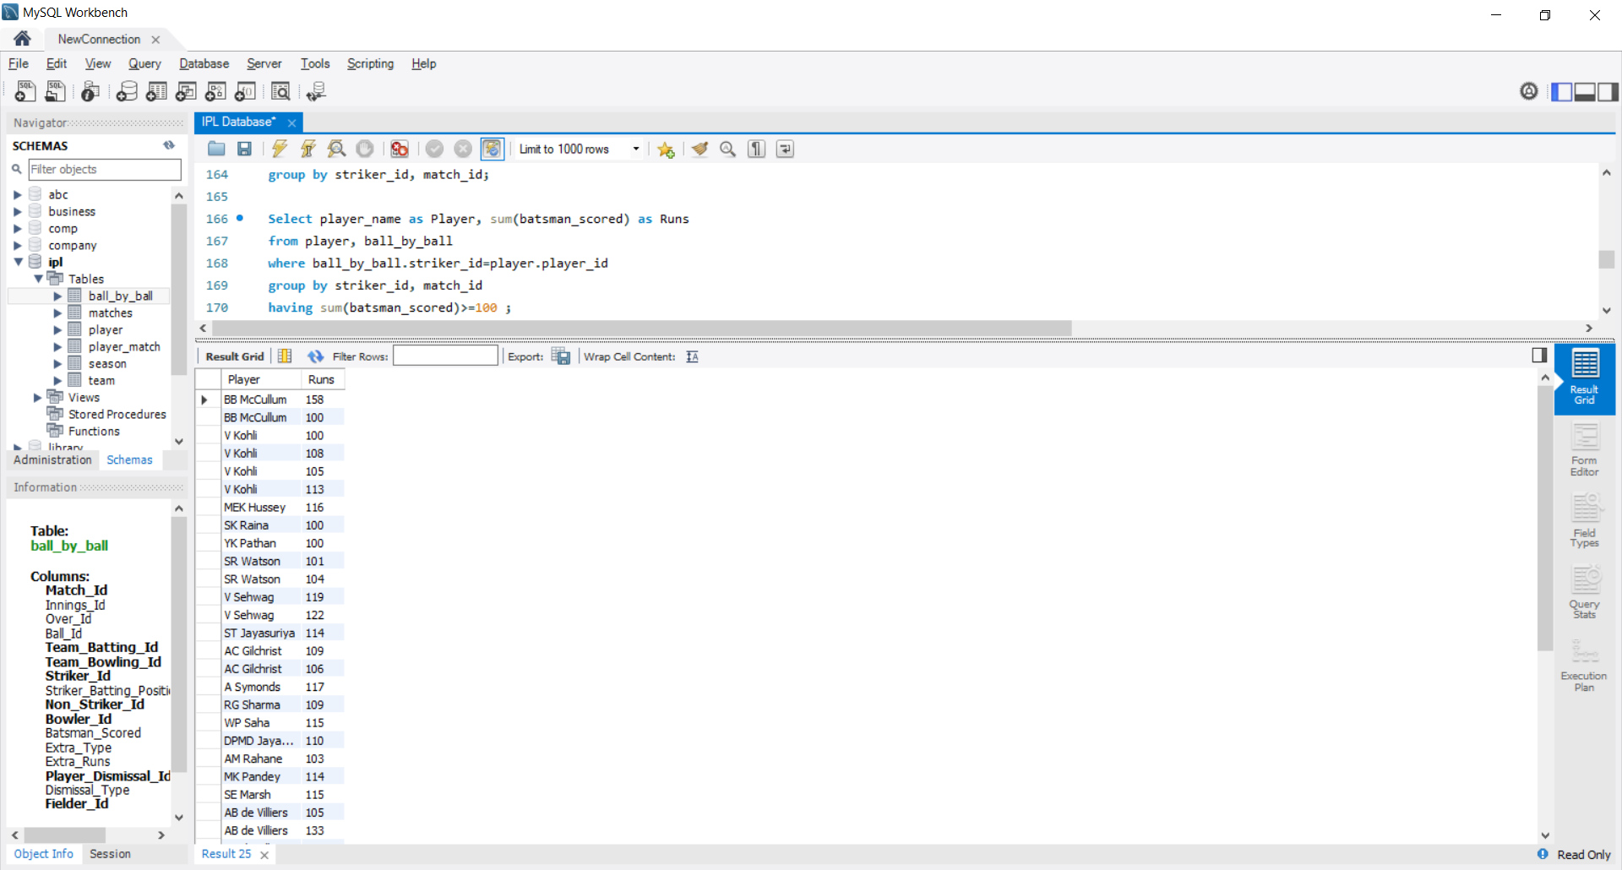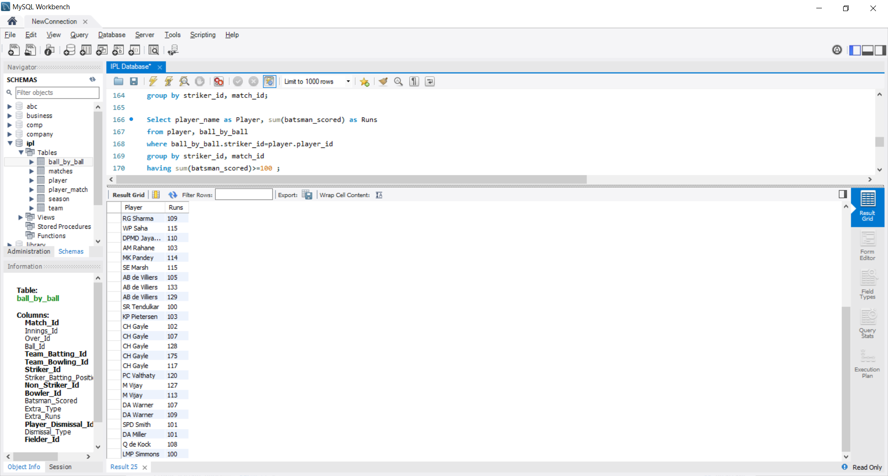

1. Create a view to answer the following:
   * Name the player who has played the maximum number of matches along with the count.
   * What is the number of matches played by Chris Gayle?

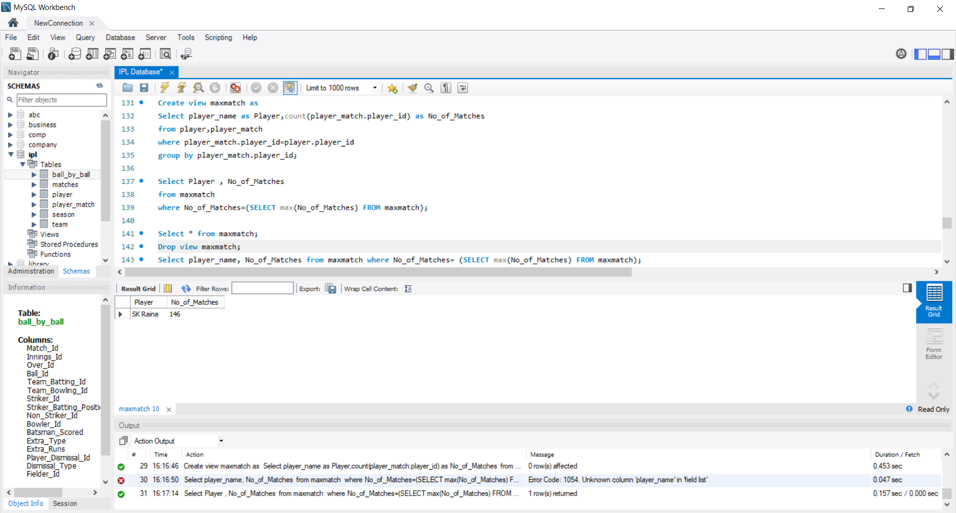

**QUERY 1**



**OUTPUT** **1**



**QUERY 2**

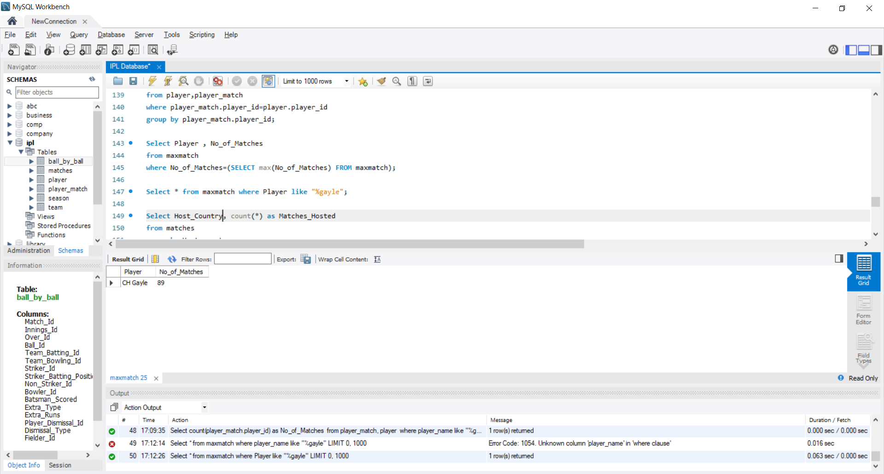

**OUTPUT** **2**



1. List the top 50 bowlers in the descending order of the number of wickets they have taken.

**QUERY**

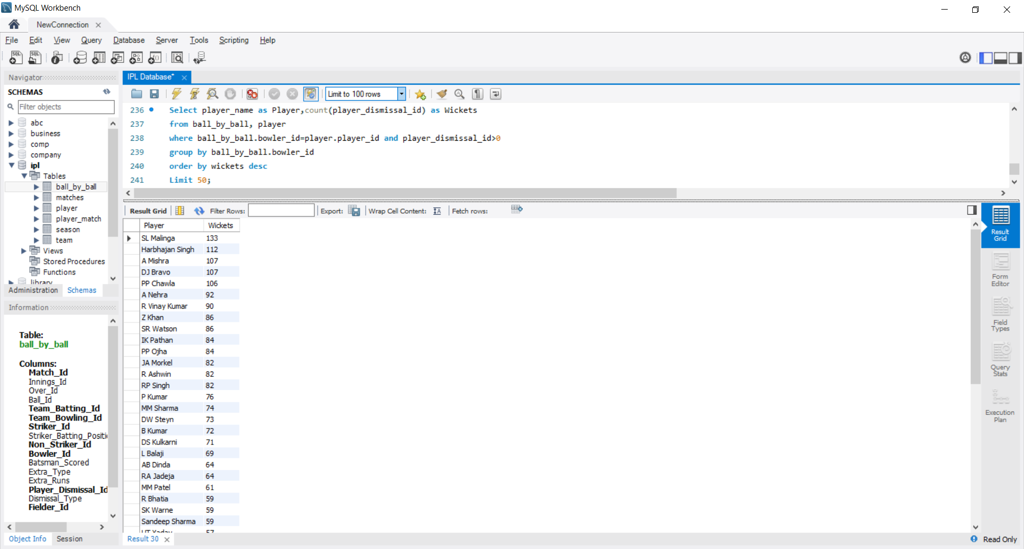

**OUTPUT**

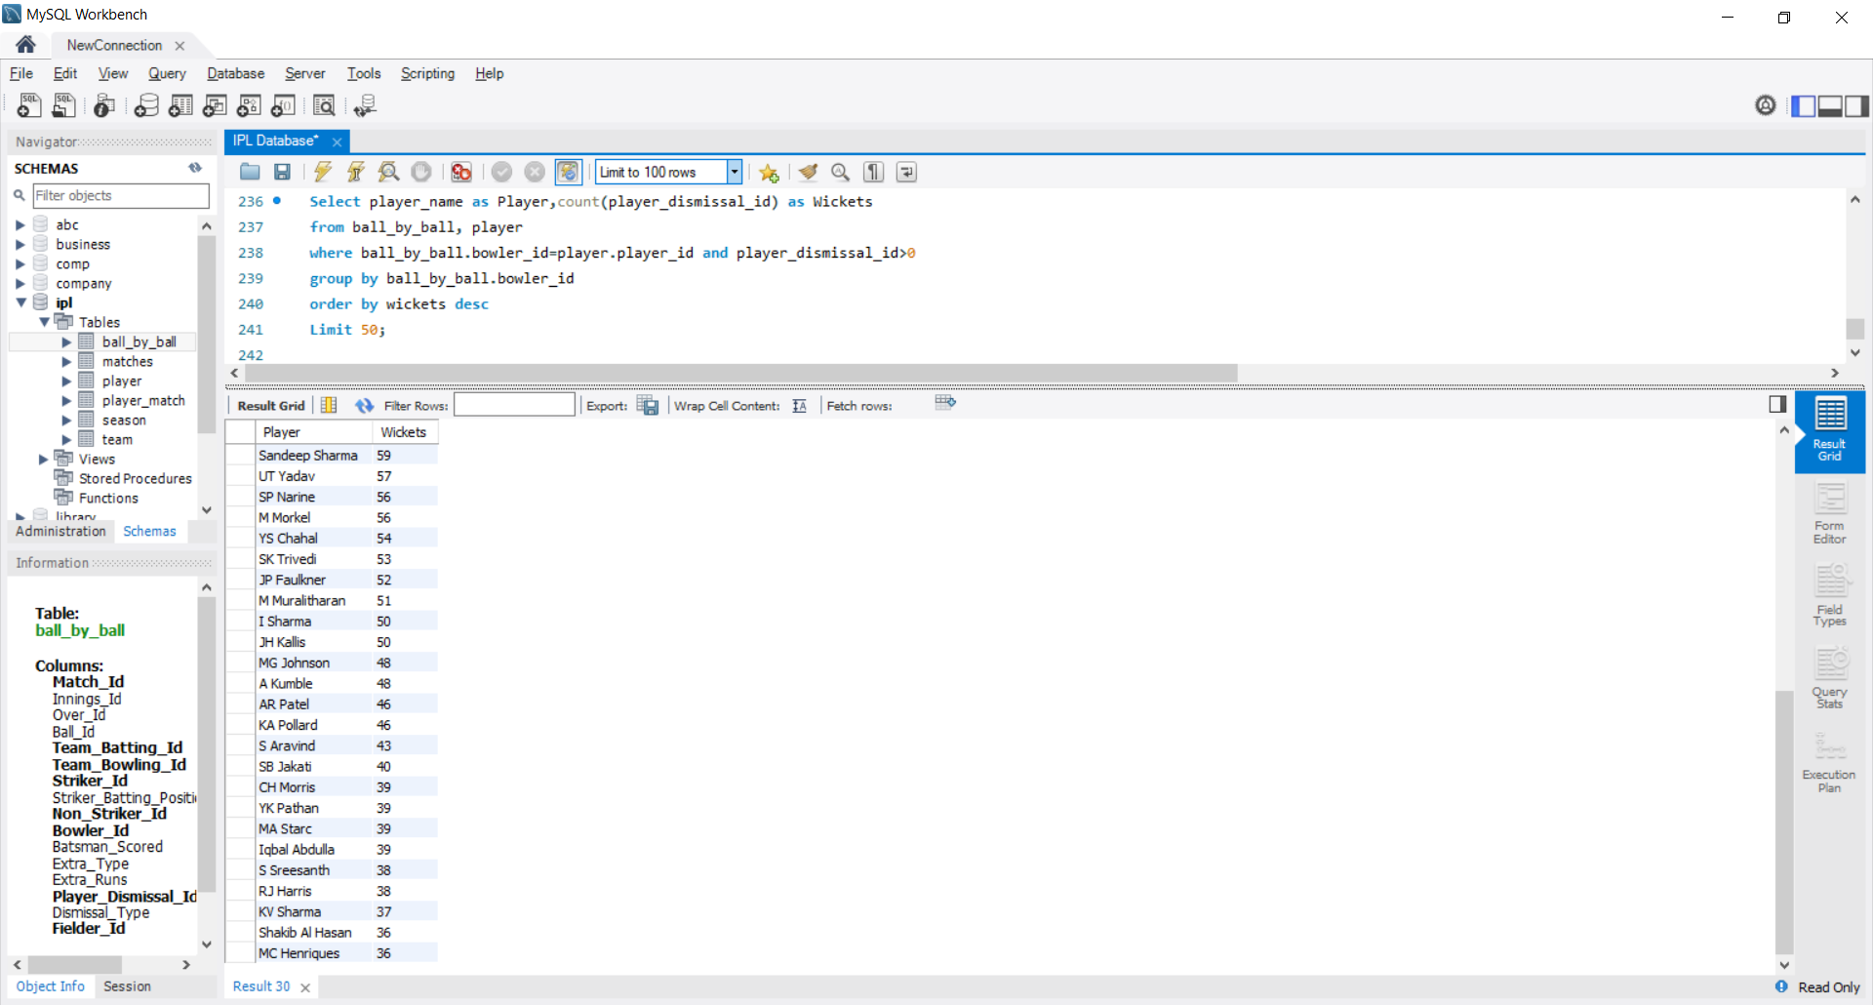

1. Create a view to answer the following:

* List the highest scores of all the batsmen.
* What is Mahendra Singh Dhoni’s highest score?

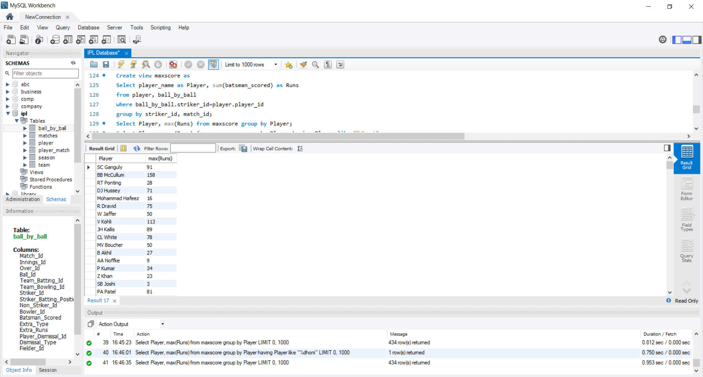

**QUERY 1**

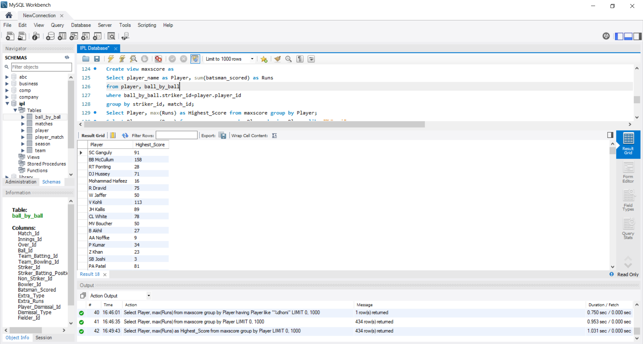

**OUTPUT 1**



**QUERY 2**

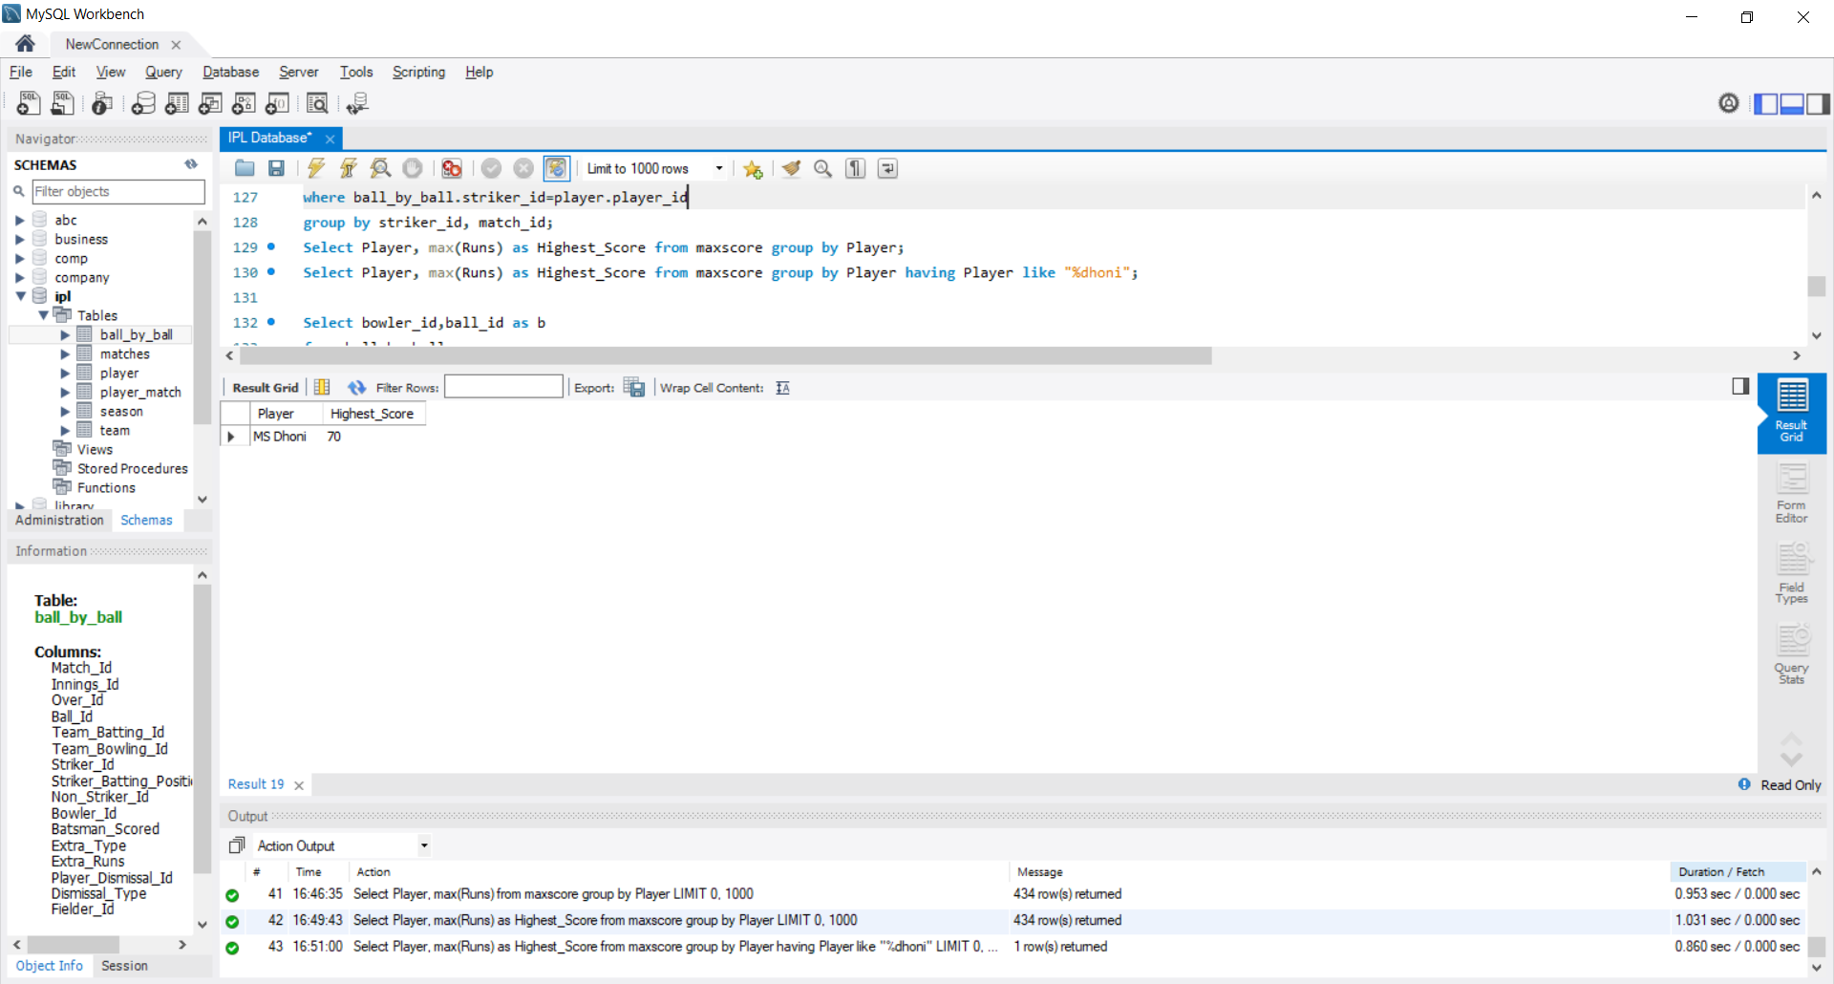

**OUTPUT 2**



**CONCLUSION**

In this project, I built a MySQL database using the Indian Premier League (IPL) dataset. The dataset consisted of 6 comma-separated-value (.csv) files that were downloaded from the Kaggle.com. During my course of database management system, I learned about the basics of database design. I designed a database that can be used by cricket enthusiasts as well as data analysts to efficiently enlist data comparisons between players and teams. This can also be very helpful to people who are involved in games like Dream11, My11Circle, etc. This project gave me the opportunity to implement my knowledge of database and database management systems. While doing this project, I also gained deeper understanding on database design and how it can be implemented in real life situations.

**REFERENCES**

* <https://www.kaggle.com/harsha547/indian-premier-league-csv-dataset> for dataset
* <https://app.diagrams.net/> for making an Entity-Relation Diagram
* <https://docs.python.org/3/> for pre-processing data
* [www.stackoverflow.com](http://www.stackoverflow.com/) for queries